Database and Management System Lab

# Lab Experiment – 8

Name: Akshat Srivastava

Batch 2

Roll No: R21442230052

Sap_ID: 500123177

Title: Use of different SQL clauses and join

Objective: To understand the use of group by and having clause and execute the

SQL commands using JOIN

1. Consider the following schema:

Student (sid, sname, age)

Match (mid, mname, venue)

Play (sid, mid, day(date))

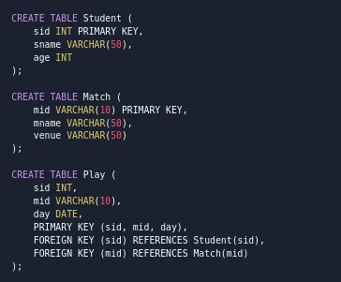

1. Populate all the tables.

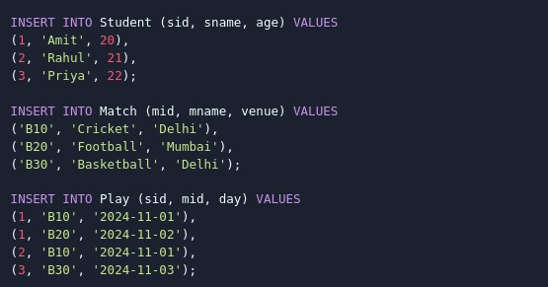

1. Find all information of students who have played match number B10.

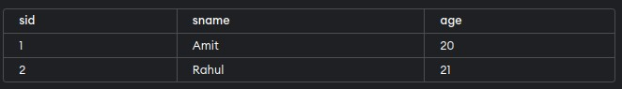

1. Find the name of matches played by Amit.

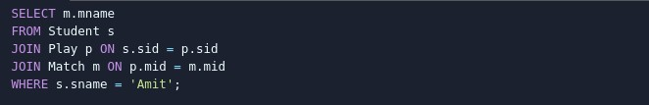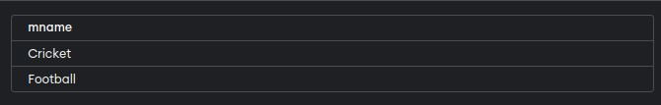

1. Find the names of students who have played a match in Delhi.

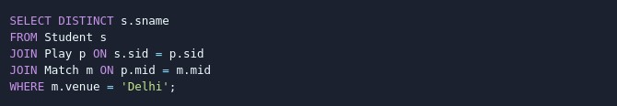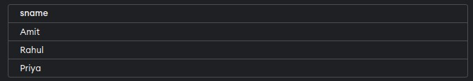

1. Find the names of students who have played at least one match.

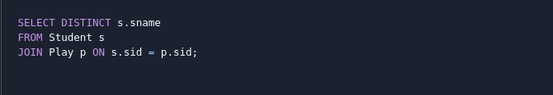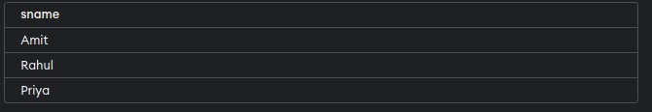

1. Find the ids and names of students who have played two different matches on the same day.

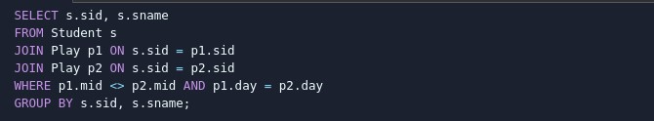

1. Find the ids of students who have played a match in Delhi or Mumbai.

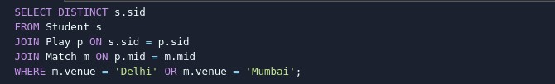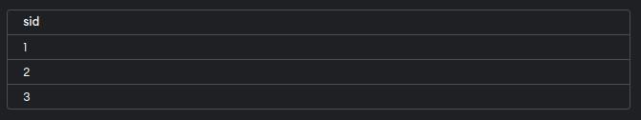

1. Find the average age of students.

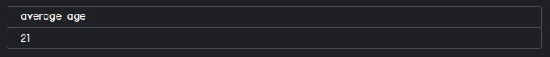

Database and Management System Lab

# Lab Experiment – 9

Name: Garvit Rana

Batch 1

Roll No: R21442230026

Sap_ID: 500119405

Title: To understand the concepts of Views.

Objective: Students will be able to implement the concept of views

1. Create table of table name: EMPLOYEES and add 6 rows

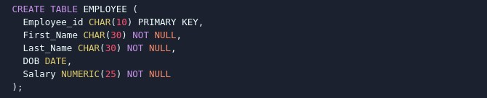

1. Create a View emp_view with Specific Columns



1. Insert Values into the View (emp_view)



1. Modify, delete and drop operations are performed on view





1. Creates a view named salary_view. The view shows the employees in department 20 and their annual salary

0